Bahria University,

Karachi Campus



LAB EXPERIMENT NO.

**03**

LIST OF TASKS

|  |  |
| --- | --- |
| TASK NO | OBJECTIVE |
| 1 | **Write a python program for approximating the roots of following functions using bisection method: a. x 3 - 9x+1 starting with the interval [2, 4]  b. 3x = √ (1 + sinx) starting with the interval [0, 1]** |
| 2 | **Write a python program for approximating the roots of following functions using falseposition method:  a. f(x) = (x−4)2 (x+2) starting with the interval [-2.5, -1.0] b. f(x) = e x (3.2sin(x)−0.5cos(x)) starting with the interval [3,4]** |

**Task 1: Write a python program for approximating the roots of following functions using bisection method:  
a. x 3 - 9x+1 starting with the interval [2, 4]   
b. 3x = √ (1 + sinx) starting with the interval [0, 1]**

**Solution a:**

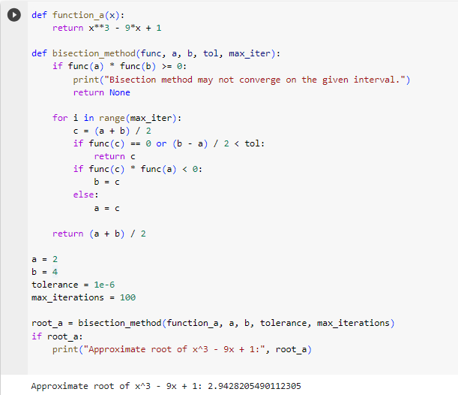

**Solution b:**

**Task 2: Write a python program for approximating the roots of following functions using falseposition method:   
a. f(x) = (x−4)2 (x+2) starting with the interval [-2.5, -1.0]  
b. f(x) = e x (3.2sin(x)−0.5cos(x)) starting with the interval [3,4]**

**Solution a:  
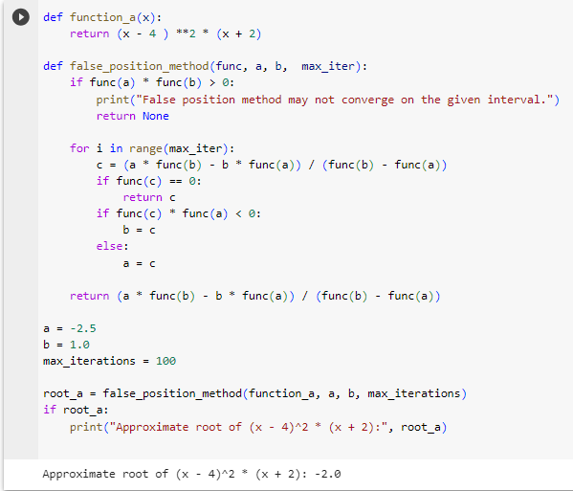**

**Solution b:**

